Sean Carlin

CAR18110827@live.nwrc.ac.uk

User Guide & Part B

User Guide & all information   
regarding Part B of the assignment.

Assignment 2

Visual Programming – Peter Wisener

Contents

User Guide 3

1. Product Section 3

1.1. How to add a new product 3

1.2. How to edit an existing product 3

1.3. How to delete an existing product 3

2. Stock Section 3

2.1. Display Stock 3

2.2. Make Sale 3

3. Reports Section 3

3.1 Low Stock Items 3

3.2 Products by Category 3

3.2 All sales 3

4. System 3

4.1 Information 3

4.2 Help 3

4.3 Exit 3

Java Collections Framework 4

What is it? 4

HashMap Classes 4

Interfaces, Abstract/Concreate Classes 4

Constructors 4

Key Methods 4

Advantages of HashMap Classes 4

Disadvantages of HashMap Classes 4

LinkedList Classes 5

Interfaces, Abstract/Concreate Classes 5

Constructors 5

Key Methods 5

Advantages of LinkedList Classes 5

Disadvantages of LinkedList Classes 5

Assignment 2

Visual Programming – Peter Wisener

# User Guide

How to use *One World Health Products*

## Product Section

### How to add a new product

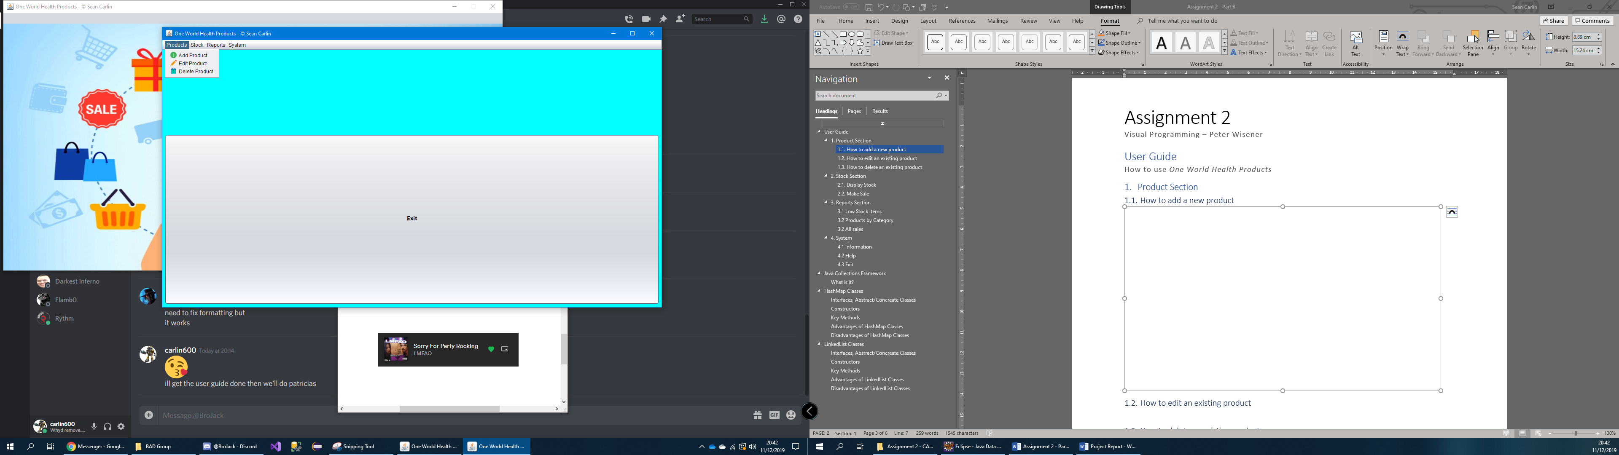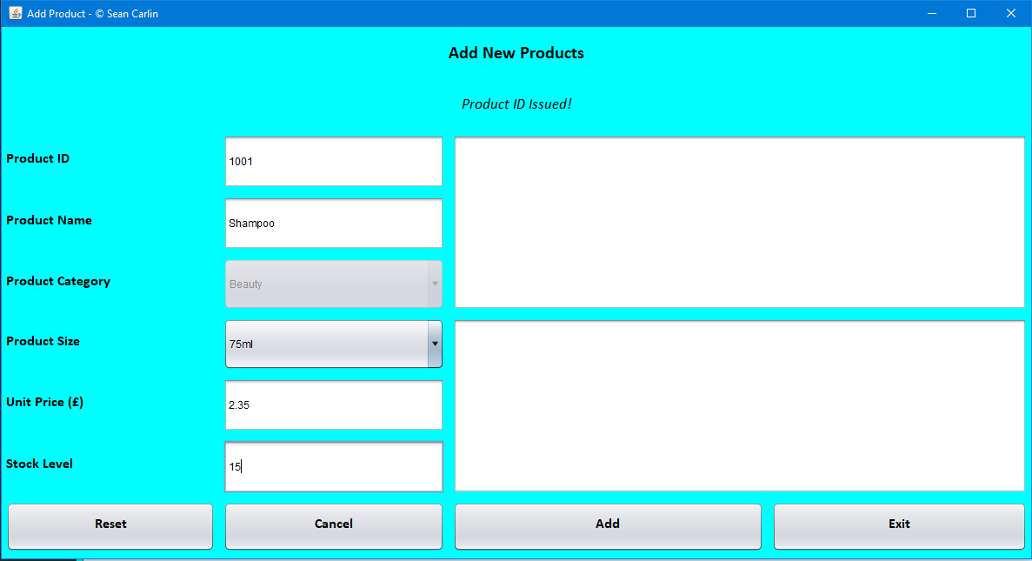

### How to edit an existing product

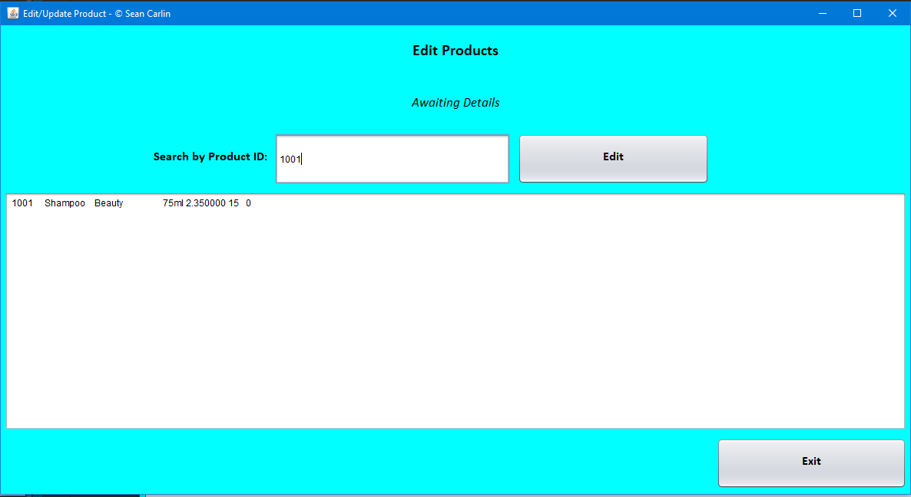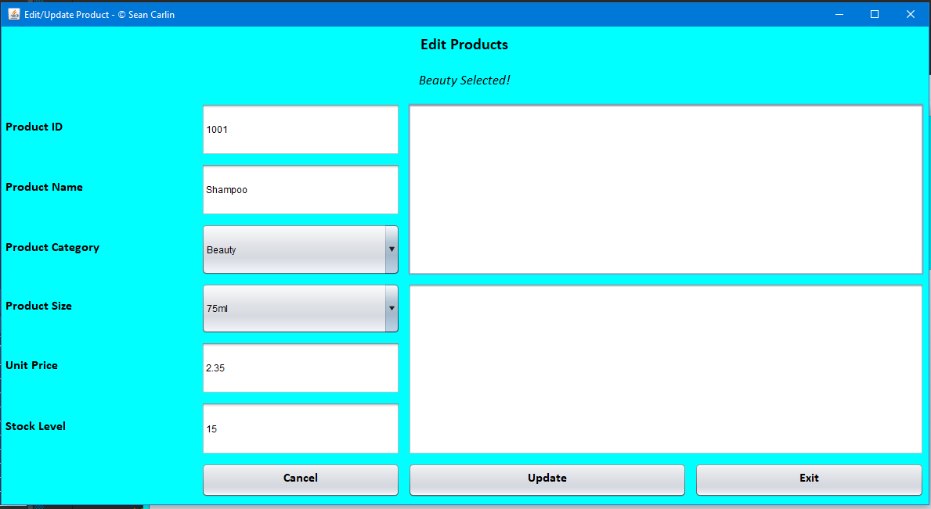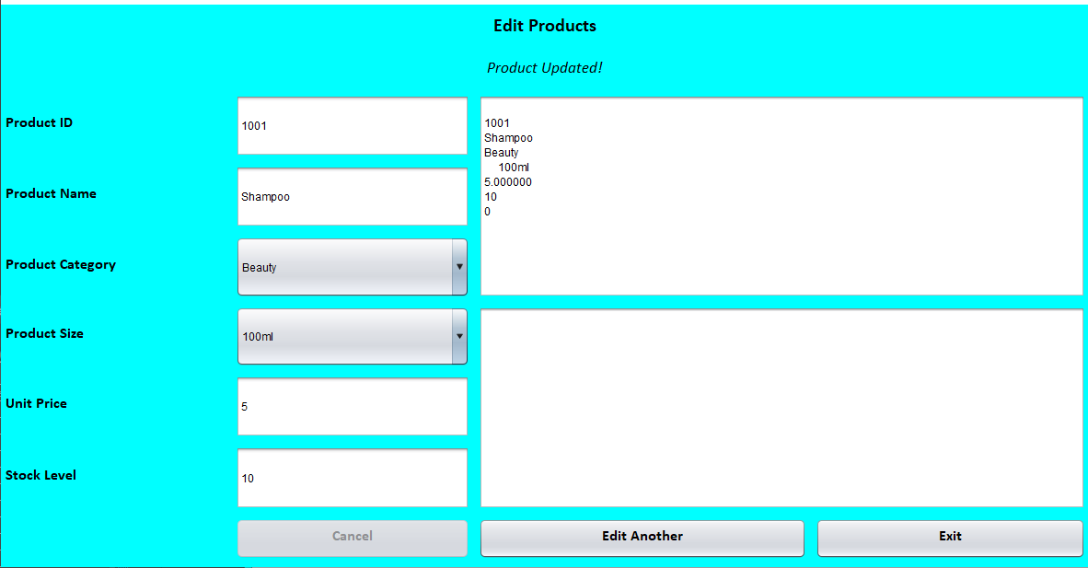

### How to delete an existing product

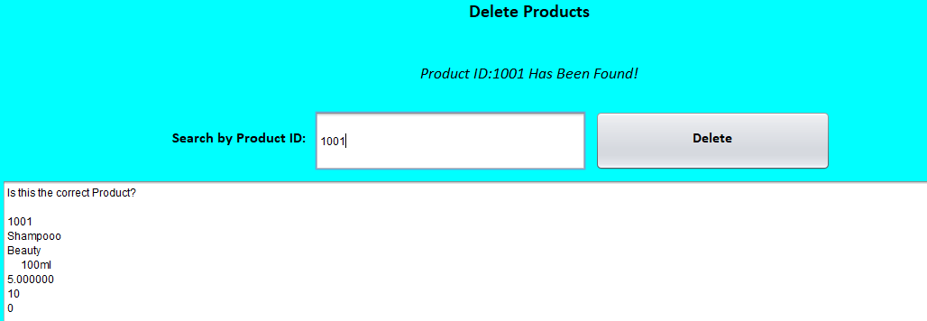

## Stock Section

### Display Stock

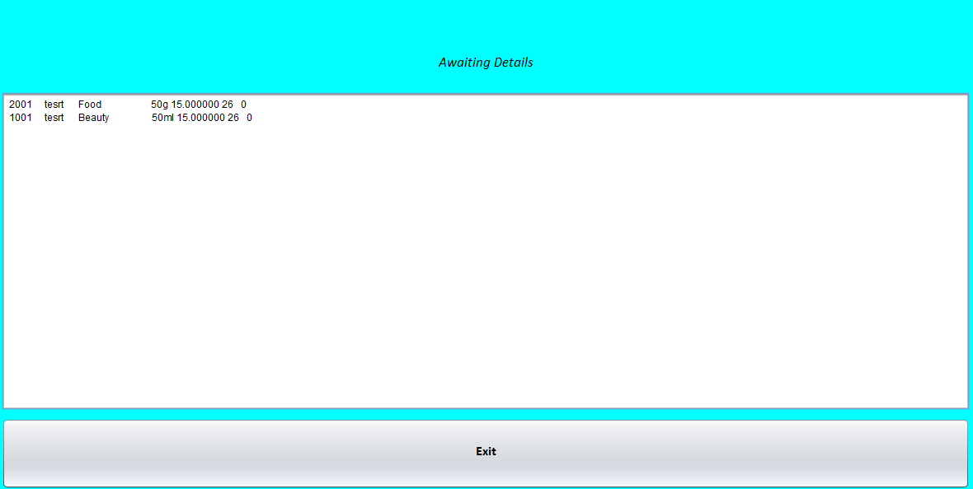

### Make Sale

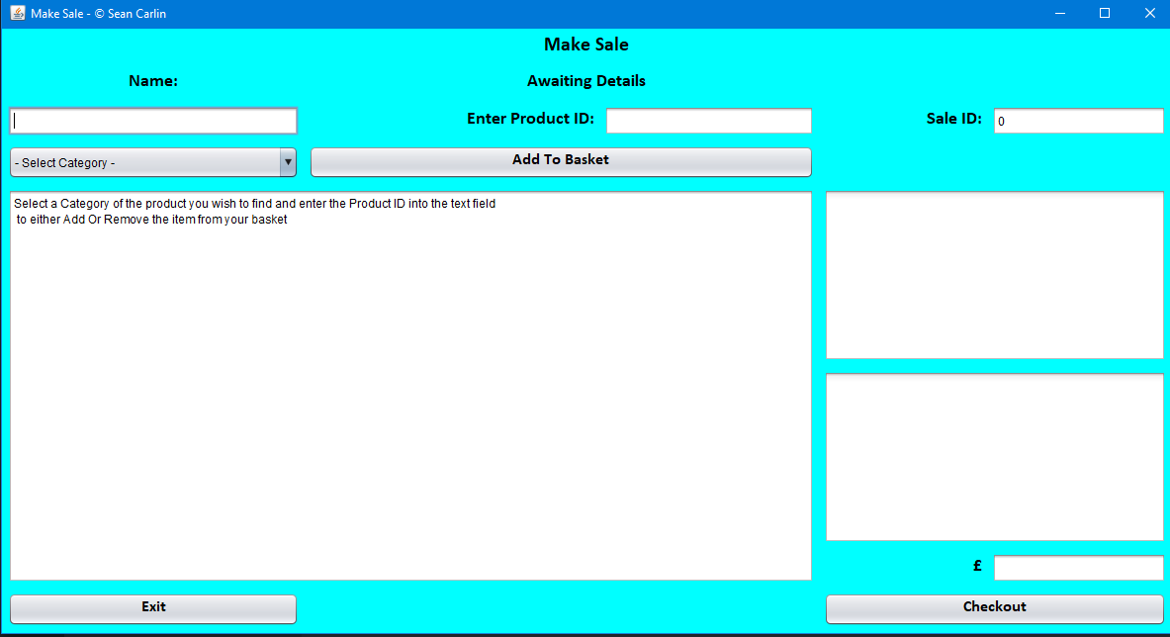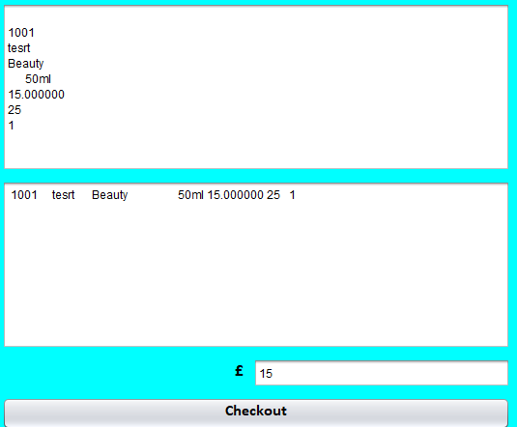

## Reports Section

### 3.1 Low Stock Items

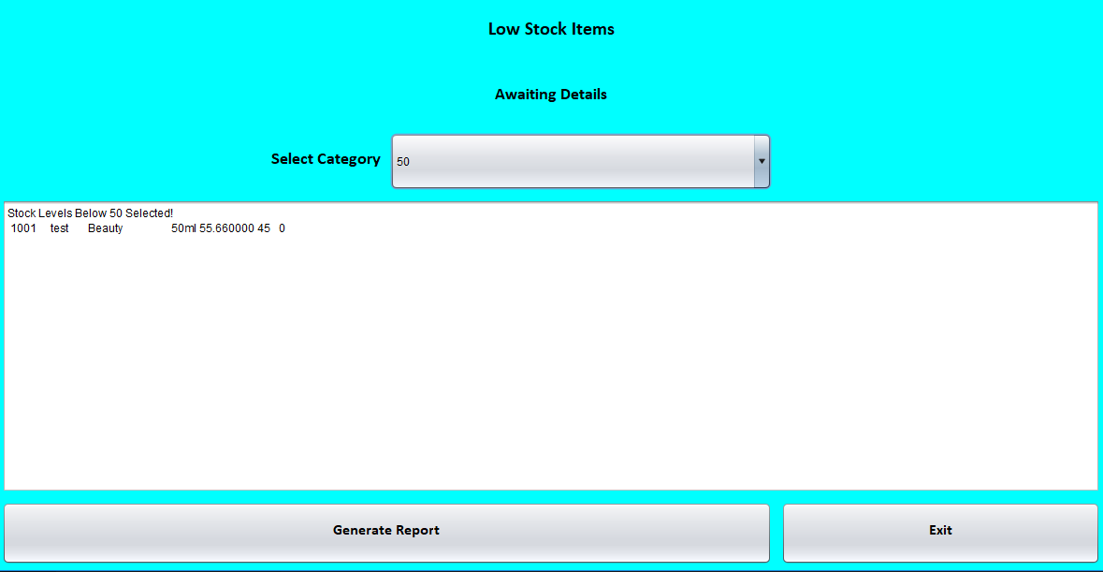

### 3.2 Products by Category

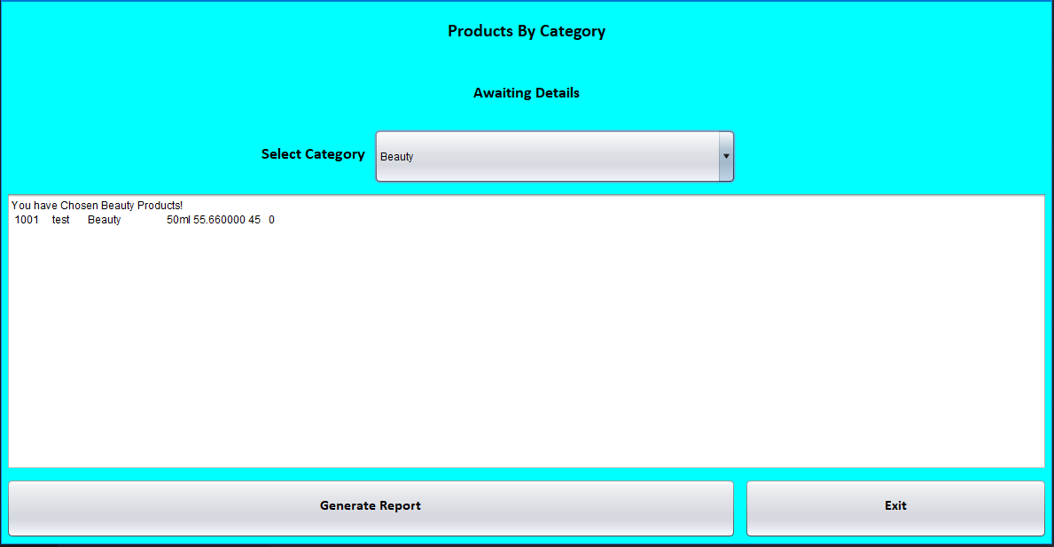

### 3.2 All sales



## System

### 4.1 Information

### 4.2 Help

### 4.3 Exit

# Java Collections Framework

## What is it?

# HashMap Classes

## Interfaces, Abstract/Concreate Classes

## Constructors

## Key Methods

## Advantages of HashMap Classes

## Disadvantages of HashMap Classes

# LinkedList Classes

## Interfaces, Abstract/Concreate Classes

## Constructors

## Key Methods

## Advantages of LinkedList Classes

## Disadvantages of LinkedList Classes